How Web Development Impacts SEO and Your Google Rankings
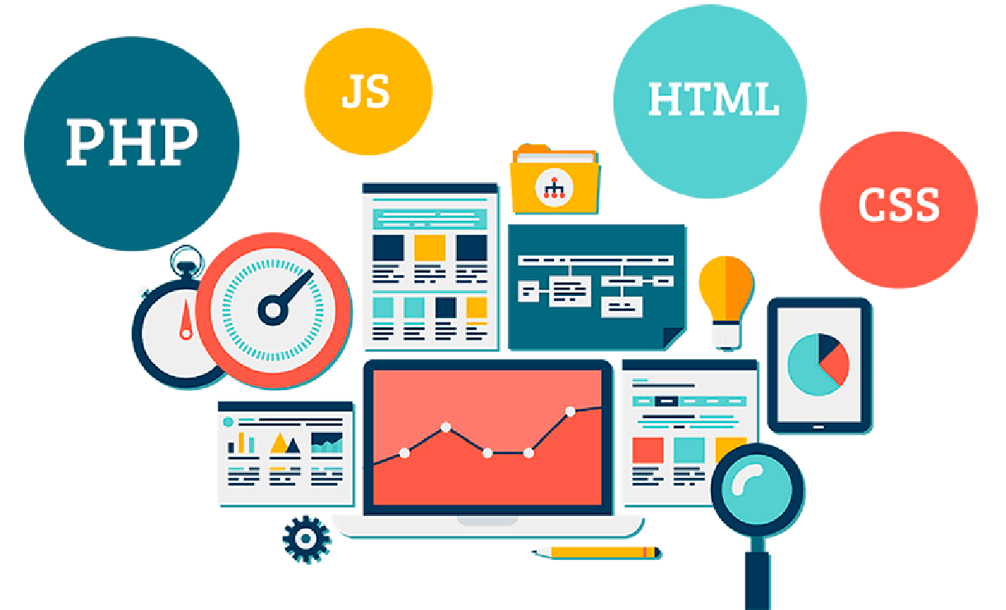

As the business environment shifts more to an online environment it becomes imperative for any business that wants to be found by its target market. A specifically created website that is unique to the business is highly significant in marketing your company while at the same time facilitating easy navigation.
However, the mere creation of a website is not sufficient for a firm. You require the site to be seen and searchable by search engines such as Google so that potential customers can see you. This is where the main interaction between website development in Dubai company and search engine optimization (SEO) enters the scene.

Web Development is the first step toward optimization of search engines:
A well-built website acts as a foundation upon which you can then optimize for SEO to increase organic traffic and ranking. Ultimately, the result of the best SEO efforts will only be marginal if there are no properly designed and coded web pages. To achieve those results, it's essential to have the right web dev agency by your side.
Here are some key aspects of website development that influence SEO include:

Site Architecture and Structure:
A logically arranged website with an easy and consistent design assists user as well as the search engine bots to crawl through the information. A clean and easily comprehendible website information architecture helps the user find what they are looking for.

Quality Site Content:
SEO always begins with quality, relevant content on websites, which is selected based on audience preferences. The content should also properly incorporate the main keyword to show the search engines that the content is relevant to the topic at hand.

Responsive Web Design:
As the usage of mobile devices keeps increasing, it is crucial to have a website that can adjust to any screen size of the device. Google also incorporates the mobile page experience into its ranking signals.

Page Speed:
Optimizing web page loading speeds benefits the users and their search rankings. Writing clean and concise code and browser caching enhances website speed.

Schema Markup:
Schema markup incorporates the use of codes to provide the website content with a structure. This helps search engines understand the content and how it should be displayed when the user types the keywords in the search engine results page (SERP).

URL Structure:
A sensible and easy-to-follow website URL structure with keywords to target helps in getting the pages indexed quickly and helps with setting the context for search engines.

Open Graph Tags:
The Open Graph tags enable one to have control over the appearance of the website page when shared on social media platforms. This increases audience and word-of-mouth traffic from Social media platforms.
In conclusion, a beautifully designed, developed, and coded website erases obstacles to ranking high in SEO and provides you with the launching pad for the subsequent stages of your SEO plan. This will become possible only when you contact with right website development company for web development services.

Impact of Technical SEO on Ranking:
The technical aspect of SEO constitutes some of the most important best practices for improving your rankings.

Even having a website professionally built for the express purpose of being SEO-friendly is only the first step. However, the actual ranking factors are the technical SEO you employ during web development and thereafter.
Some key technical SEO best practices include:

XML Sitemaps:
An XML sitemap that is well formulated enables the search engines to discover new pages for the purpose of indexing in a faster way. Almost all the big sites have their sitemaps.

Metadata Optimization:
Meta tags such as page title tags, meta descriptions, alt text, etc., assist the search engine in identifying the content’s main themes and topics. Some of these need to be optimized appropriately for webpage optimization to be a success.

Indexability Testing:
While Flexible Web Design from web dev agencies in Dubai lets the site get indexed, testing allows the search engines to crawl all the pages without hindrances such as wrong robotTxt file.

Canonicalization:
By setting up well-structured and organized canonical tags one can prevent the occurrence of issues such as duplicate content or indexation problems since the tags inform the search engines on which single URL version of a webpage is correct.

Crawling and Rendering:
Its benefits indexation for a faster rate of ranking potential by helping to make pages easily discoverable and easy to render by crawlers.

Site Performance:
Since site speed is one of the ranking factors, such factors as limited server requests, improved caching, image compression, and other technical improvements are considered.
Considering that search algorithms value what the pages offer and whether they satisfy the search intent, quality technical SEO establishes the right signs.

Technical Web Development and its effects on Search Engine Optimization:

Website development refers to the entire layout and visible components of the website, the actual coding and framework that runs the site. Technical issues are important in development and their effects are clearly observable in SEO.
Some key considerations include:

Code Quality and Accessibility:
Semantic and clean codes coupled with a thin and error-free base reduce scroll depth and increase crawling availability and page rendering. This directly leads to enhanced indexing and improved rankings on the search engine result pages.

Site Security:
Complete secure communication through HTTPS and other necessary web security protocols informs search engines that the site has adhered to quality practices, leading to trust as well as prominence.

Page Speed and Performance:
Many factors such as images, file types, minimal plugins, cache, and more lead to faster sites in rankings and this is essential in search rankings. The effect of page load time on SEO increases with the years.

Mobile Responsiveness:
As Google labels sites that aren’t mobile-friendly, web development must guarantee quick and convenient work of the mobile site. This is increasingly affecting the search visibility and click-through rate from search.
Thus, technical web development either supports or disrupts a site’s chance of ranking high in SEO – and that’s why cooperation with an SEO-focused web dev agency pays off.

Key Takeaways:
In this blog, we discovered that increasing the exposure of your website and achieving higher rankings on Google can appear to be challenging. However, just remember these few key points: However, just remember these few key points:

- In the case of SEO, quality web design and custom web development constitute the framework.
- Website structure, informative content quality, and metadata provide the opportunities to start optimization.
- Technical SEO is an ongoing process that ensures that the code, site structure, and performance all adhere to the ranking factors.
- More specifically, continued search ranking analysis, user behavior study, and algorithm modifications should further develop your website SEO strategy in the long run.
First and foremost, ensure that you have contacted the right website development Dubai agency for website development. Next, go even further and commit to technical SEO as an ongoing process that requires constant attention. In the long run, this website development company strategy produces actual improvements in search engine ranking as well as related increases in organic traffic and sales.
The best part? Some of these fundamentals also have further advantages other than SEO as well, for instance, enhancing the overall user experience.
Therefore, web development with a strong SEO focus should not be an issue if you plan to expand your presence online this year. The search visibility and the bottom-line payoff will surely make it worth the effort!

